Chapter 3, Solution 26

At node 1,

(1)
At node 2,
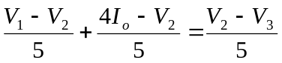 (2)
But 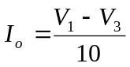. Hence, (2) becomes
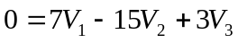 (3)
At node 3,
(4)
Putting (1), (3), and (4) in matrix form produces

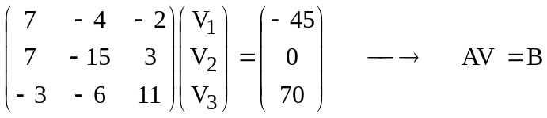
Using MATLAB leads to
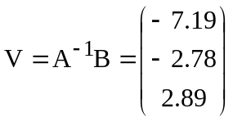
Thus,
V₁ = –7.19V; V₂ = –2.78V; V₃ = 2.89V.

